EXPERIMENT 4

Name: Arav Desai | Roll No: 3
Subject: Programming and problem solving | Class/Batch: AIML A
Date of Performance: 14/8/2024 | Date of Submission:

AIM

Aim : To write and execute C programs using branching statements.
Code

I. Accept a number from user and display if number is positive, negative or zero
#include <stdio.h>

int main() {
int number;

printf("Enter a number: ");
scanf("%d", &number);

if (number > 0) {
printf("The number is positive.\n");
} else if (number < 0) {
printf("The number is negative.\n");
} else {
printf("The number is zero.\n");
}

return 0;
}
Output
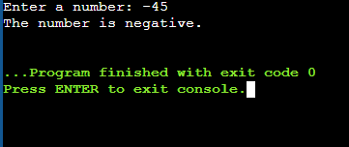

Code
II. Accept three numbers from user and display the largest number. a. Using if else if ladder b. Using ternary operator

Using If-else ladder:
#include <stdio.h>

int main() {
int num1, num2, num3, largest;

printf("Enter three numbers: ");
scanf("%d %d %d", &num1, &num2, &num3);

if (num1 >= num2 && num1 >= num3) {
largest = num1;
} else if (num2 >= num1 && num2 >= num3) {
largest = num2;
} else {
largest = num3;
}

printf("The largest number is: %d\n", largest);

return 0;
}
Using ternary operator:
#include <stdio.h>

int main() {
int num1, num2, num3, largest;

printf("Enter three numbers: ");
scanf("%d %d %d", &num1, &num2, &num3);

largest = (num1 >= num2) ? ((num1 >= num3) ? num1 : num3) : ((num2 >= num3) ? num2 : num3);

printf("The largest number is: %d\n", largest);

return 0;
}
Output

Using if-else ladder:
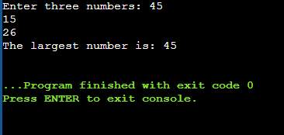
Using ternary operator:
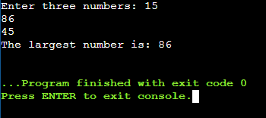
Code

III. Write a program to accept the input from the user and display if the number is even or odd

#include <stdio.h>

int main() {
int number;

printf("Enter an integer: ");
scanf("%d", &number);

if (number % 2 == 0) {
printf("The number %d is even.\n", number);
} else {
printf("The number %d is odd.\n", number);
}

return 0;
}
Output

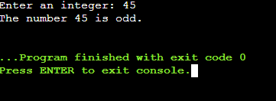

Code

IV. Write a program to accept the year from the user and display if it is a leap year or not.

#include <stdio.h>

int main() {
int year;

printf("Enter a year: ");
scanf("%d", &year);

if ((year % 4 == 0 && year % 100 != 0) || (year % 400 == 0)) {
printf("The year %d is a leap year.\n", year);
} else {
printf("The year %d is not a leap year.\n", year);
}

return 0;
}
Output

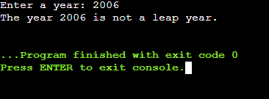

Code

V. Write a program to accept the length of three sides of a triangle and to test and print the type of triangle as equilateral, isosceles or scalene or none.
#include <stdio.h>

int main() {
float side1, side2, side3;

printf("Enter the lengths of the three sides of the triangle: ");
scanf("%f %f %f", &side1, &side2, &side3);

if (side1 == side2 && side2 == side3) {
printf("The triangle is equilateral.\n");
} else if (side1 == side2 || side1 == side3 || side2 == side3) {
printf("The triangle is isosceles.\n");
} else if ((side1 + side2 > side3) && (side1 + side3 > side2) && (side2 + side3 > side1)) {
printf("The triangle is scalene.\n");
} else {
printf("The lengths do not form a triangle.\n");
}

return 0;
}

Output

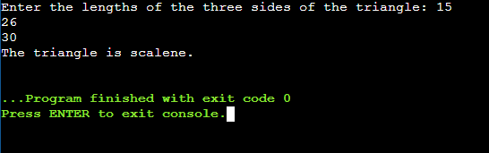

Code

VI. Accept the percentage from the user and display the grade. (90 & above “A”, 81 TO 89 “B” 71 to 79 “C” 61 to 69 “D” else F)

#include <stdio.h>

int main() {
float percentage;
char grade;

printf("Enter your percentage: ");
scanf("%f", &percentage);

if (percentage >= 90) {
grade = 'A';
} else if (percentage >= 81) {
grade = 'B';
} else if (percentage >= 71) {
grade = 'C';
} else if (percentage >= 61) {
grade = 'D';
} else {
grade = 'F';
}

printf("Your grade is: %c\n", grade);

return 0;
}
Output
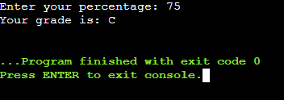

Code
VII. Write a program to implement calculator (add, sub, mul, div and modulo) using switch case
#include <stdio.h>

int main() {
char operator;
float num1, num2, result;

printf("Enter an operator (+, -, *, /, %): ");
scanf("%c", &operator);

printf("Enter two numbers: ");
scanf("%f %f", &num1, &num2);

switch (operator) {
case '+':
result = num1 + num2;
printf("Result: %.2f\n", result);
break;
case '-':
result = num1 - num2;
printf("Result: %.2f\n", result);
break;
case '*':
result = num1 * num2;
printf("Result: %.2f\n", result);
break;
case '/':
if (num2 != 0) {
result = num1 / num2;
printf("Result: %.2f\n", result);
} else {
printf("Error: Division by zero is not allowed.\n");
}
break;
case '%':
if ((int)num2 != 0) {
result = (int)num1 % (int)num2;
printf("Result: %.0f\n", result);
} else {
printf("Error: Division by zero is not allowed.\n");
}
break;
default:
printf("Error: Invalid operator.\n");
break;
}

return 0;
}

Output

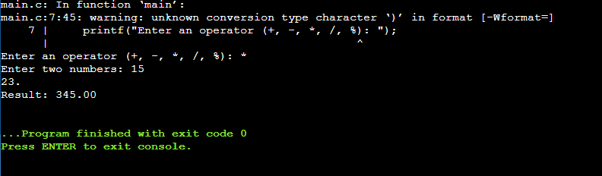

Conclusion

In conclusion, the project aimed at writing and executing C programs using branching statements was a comprehensive and enlightening experience. By implementing if-else ladders, switch cases, and ternary operators, we not only enhanced our problem-solving skills but also developed a deeper understanding of decision-making processes in C programming. These fundamental concepts are crucial for controlling the flow of execution based on different conditions, enabling us to create more dynamic and interactive programs. The practical exercises reinforced theoretical knowledge and provided a solid foundation for tackling more complex programming challenges in the future.

Assessment

Timely Submission  (7) | Presentation  (06) | Understanding  (12) | Total  (25) | Sign

